📘 Hypothesis Testing – t-test & Chi-Square

Level: Beginner / Intermediate

🧠 1️⃣ Concept Explanation (Simple & Clear)
Term | Meaning
Hypothesis | A claim or assumption we want to test.
Null Hypothesis (H₀) | No difference or no effect (status quo).
Alternative Hypothesis (H₁) | There is a difference or effect.
p-value | Probability of results happening by chance.
Significance Level (α) | Threshold to reject H₀ (commonly 0.05).
👉 Goal of Hypothesis Testing:
To decide if a result is statistically significant or just happened by chance.

🎯 2️⃣ Types of Tests Covered
Test | Used For | Example
t-test | Compare means of two groups | Avg. height of boys vs girls
Chi-Square Test | Compare categories / frequencies | Does gender affect buying choice?

🧪 3️⃣ Practical Example – Real World

✏ Example 1: t-test (Mean Comparison)
A health researcher tests if a new diet changes average weight.
- H₀: No difference in weight after diet
- H₁: Diet causes weight change
If p-value < 0.05 → Diet works ✅

✏ Example 2: Chi-Square (Category Relationship)
A store checks if gender affects product preference (Shoes vs Clothes).
- H₀: Gender and choice are independent
- H₁: Gender influences choice

💻 4️⃣ Python Code (With Explanation)

🧪 A) t-test in Python
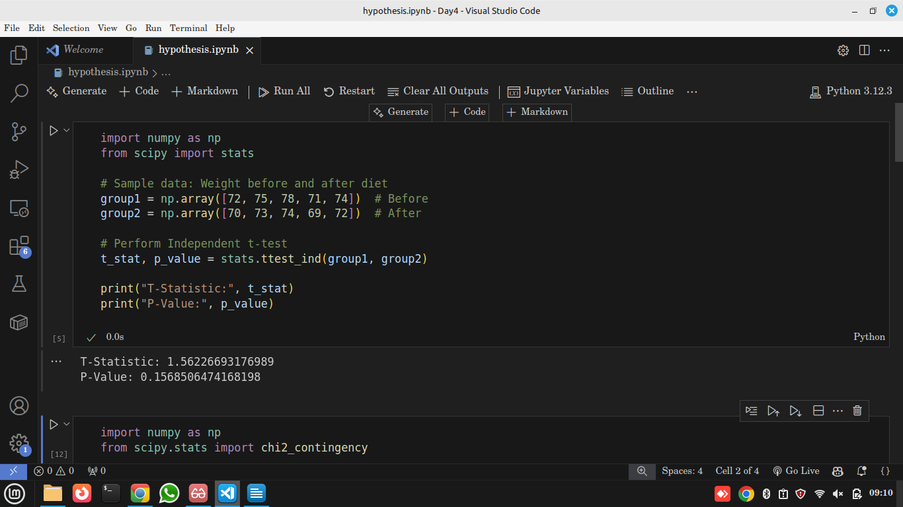
🔍 Code Explanation:
- ttest_ind() → Compares means of two groups.
- p_value < 0.05 → Reject H₀ → Significant difference.

📊 B) Chi-Square Test in Python

Example: Gender vs Product Preference
Gender | Shoes | Clothes | Electronics
Male | 40 | 25 | 35
Female | 30 | 50 | 20

🧪 Hypotheses for Chi-Square Test
Type of Hypothesis | Statement
Null Hypothesis (H₀) | Gender and product preference are independent. That means males and females choose products in the same pattern — gender does not affect what they prefer.
Alternative Hypothesis (H₁) | Gender and product preference are dependent. That means males and females have different product preferences — gender influences what they prefer.

✅ Python Code
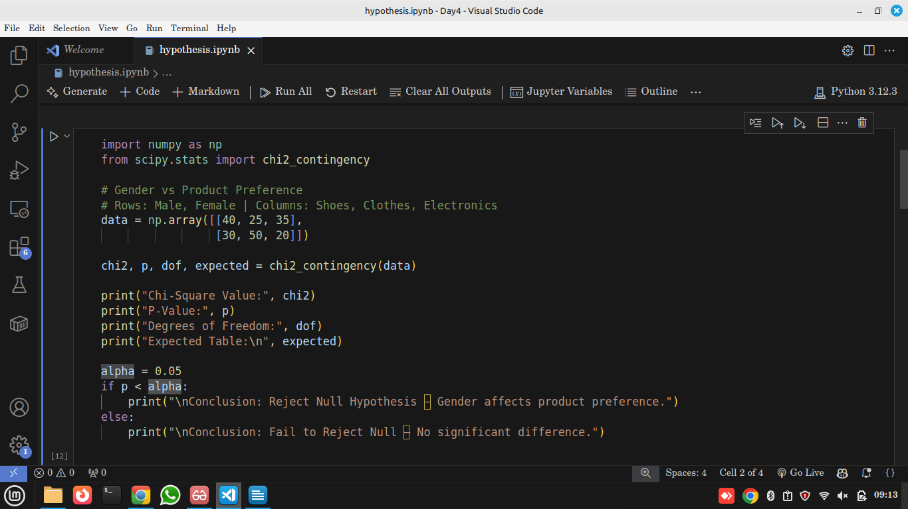

📖 Code Explanation (in Simple English)
Line | Explanation
data = np.array(...) | This is our observed data from a survey.
chi2_contingency(data) | Performs Chi-Square Test.
chi2 | Measures difference between observed vs expected.
p | Probability — if p < 0.05, gender affects preference.
expected | What counts should look like if no relationship exists.

💡 Insight for Students
- If p < 0.05 → Gender influences what people buy 🛍️
- If p > 0.05 → No difference → Men & women buy randomly

💡 5️⃣ Insights – Why It Matters
Insight | Importance
Supports Data-Driven Decisions | No guessing, pure statistics
Used in A/B Testing | Marketing, design experiments
Validates Scientific Research | Medicine, psychology, business

🌍 6️⃣ Real-World Applications
Field | Real Use Case | How Hypothesis Testing is Used
Health & Medicine | Test drug effectiveness | Researchers compare two groups: one using the new drug and one using a placebo. They perform a t-test to check if the drug truly lowers blood pressure more than placebo. If p < 0.05, they conclude the drug works.
Business & Tech | A/B Test for Website Design or Ads | A company shows Design A to 100 users and Design B to another 100 users. They compare average clicks or sales using a t-test to see which design performs better. Helps make data-driven decisions, not guesses.
Education | Compare teaching methods | A school tests if a new teaching method improves exam scores. Group 1 learns traditionally, Group 2 uses new method. A t-test checks if score differences are significant or random.
Marketing | Gender purchase behavior (Chi-Square Test) | A store checks if males and females buy different types of products (shoes, clothes, electronics). A Chi-Square Test is used to see if buying choice depends on gender OR if it’s random.
Manufacturing | Quality Control | Factories test if products from Machine A and Machine B have the same defect rate. Hypothesis testing helps decide if a machine needs repair.
Sports Science | Athlete Performance Comparison | Coaches use t-tests to compare average running times before and after training programs to see if training truly improved performance.
Psychology | Behavior & Treatment Studies | Psychologists test if therapy changes patient anxiety scores. Hypothesis testing confirms if improvement is real, not by luck.

📝 7️⃣ 15-Minute Assignment (Class Activity)
Task: Perform a t-test
- Collect test scores of two classes (Class A & B, 5 students each)
- Use Python to test if average scores differ
- Interpret p-value

